

Pax Place - Holiday Let

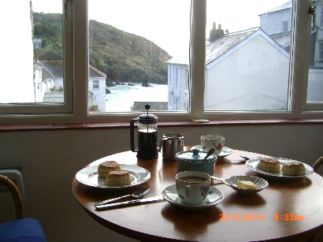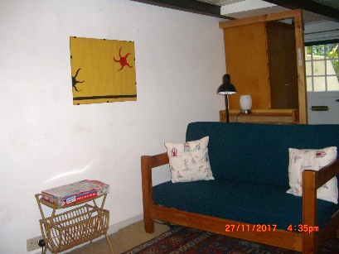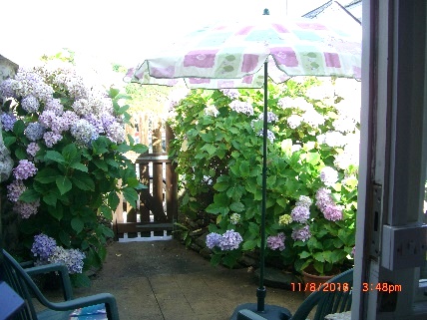Pax Place, Portloe, Cornwall, TR2 5QX

2018 - Particulars, Terms and Conditions

1 Bedroom (2 adults) - 2 sitting rooms - l bathroom - I shower room

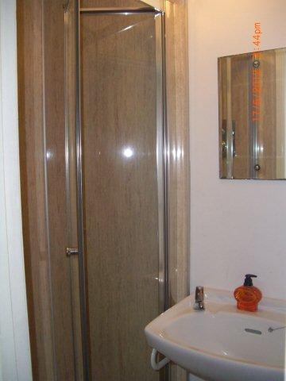Set in the centre of the pretty coastal fishing village of Portloe Pax Place enjoys views over the harbour and cliffs. The accommodation of sitting room and well equipped bespoke kitchen with all mod cons on the ground floor, bedroom and shower room upstairs and a sitting room, bathroom, facilities for making tea and refrigerator for cool drinks and patio downstairs is ideal for a holiday. Small well behaved dog welcome.

Pax is beside a stream running into the harbour so there should be no reason not to sleep peacefully in the bedroom overlooking the Jacka and cliffs without being disturbed and being so close to the sea to take an early morning swim before setting off for the day.

**Arrival/Departure:** Friday. Linen provided. No towels or beach towels.

**Equipment:** Refrigerator/freezer, microwave/oven, electric hob, clothes washer, kettle, toaster, TV with DVD, radio, books, cards and board games. Electric thermostatically controlled wall panel heaters.

Directions…

**By Car:** From Tregony follow signs to Veryan/St Mawes until petrol

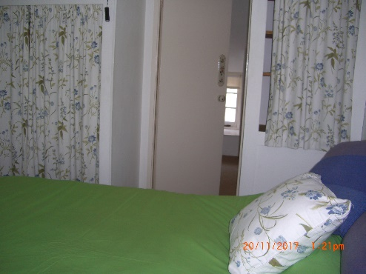station and shop where you fork left. Continue until sign to Portloe to

left. Keep on the road down the hill and continue past car park to Church and phone box on your right. Pax Place is the dark blue front door opposite the

Church.

Parking between Pax Place and the harbour or by the Church.

Car park about 5 minute walk away.

**By Train and Bus:** To Truro and occasional bus to Portloe.

**By Plane:** to Newquay.

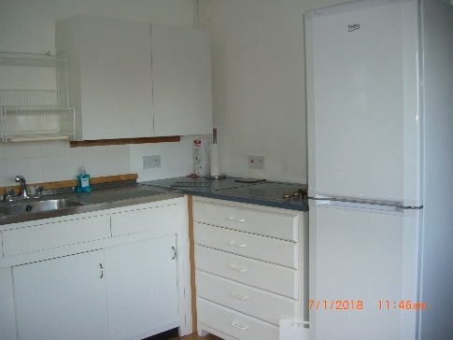 Local Area…

* **Swim** in Portloe harbour or nearby Carne/Pendower beach.
* **Walk** the costal path passing the door and other footpaths
* **Eat out** in Portloe at the Ship, Lugger Hotel or nearby at the Nare Hotel.
* **Explore** National Trust and other properties and gardens
* **Food and Petrol** Buy newspapers and shop at Texaco garage (passed on

your way to Portloe) or close by in Veryan and Tregony.

* **Bus** stop to Truro outside the Church opposite front door.

Terms & Conditions...

Accommodation for 1 or 2 adults. Sorry, no children or smoking. Small well-behaved dog welcome at £25.00 a week.

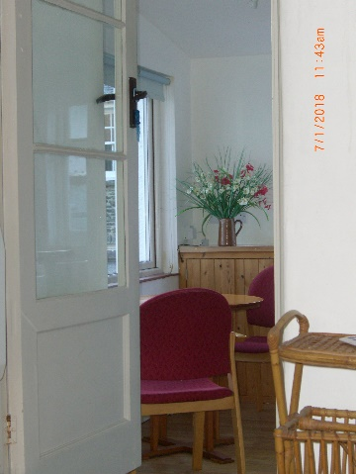Week commences 3.30pm on the first Friday of your holiday and ends at 10am on the Friday of your departure.

Deposit: £100.00

Payment: Due four weeks before your holiday starts. Non-payment of the balance of the rent by the due date shall be construed as a cancellation of the contract. If Pax Place cannot be re-let you will be responsible for the full cost of the holiday.  If Pax Place unavailable due to circumstances outside my control the rental money received will be returned.

**Key:** Arrangements will be posted on completion of payment for holiday let together with an inventory.

Please check inventory when you arrive and let me know of any missing items or breakages. Complaints cannot be accepted after the tenancy has ended.

The hirer is responsible for any loss or damage to the property (reasonable wear and tear excluded), for taking good care of Pax Place and leaving it in a clean and tidy condition. Should it be found that an excessive amount of cleaning is required a charge will be made.

Electricity is included in the rent except in low season.

Broadband may be accessed through BT Fon. All information is given in good faith and no responsibility taken for any errors or omissions.



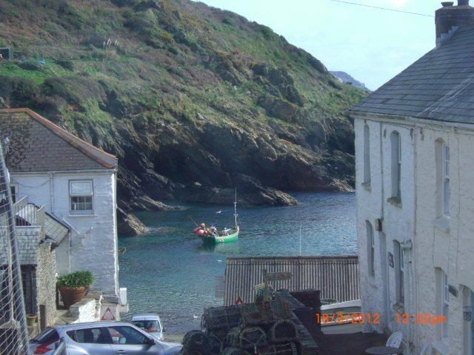 Availability 2018 …

|  |  |
| --- | --- |
| **Dates** | **Price for 7 nights (£)** |
| Friday 27 April to 24th May | £500.00 |
| Friday 25th May to 28th June | £575.00 |
| Friday 29 June to 26 July | £725.00 |
| Friday 27 July to 30 August | £850.00 |
| Friday 31 August to 4 October | £550.00 |
| Friday 5 October to 1 November | £440.00 |

View from cottage

Contact Details…

For further information about Pax Place or to confirm availability

(Please remember to state the planned date of your visit and duration):

Email:[jenpax1@yahoo.co.uk](mailto:jenpax1@yahoo.co.uk)

Telephone:01386 840272

## Post: Mrs A. J. Kissel, Garden Cottage, Chipping Campden, GL55 6AL



Booking Form for 2018…

## Please complete the form and send with cheque by post or email for bank details:

Name(1): ....................................................................................................................................................................

Name(2) .....................................................................................................................................................................

Address:......................................................................................................................................................................

………………………….........................................................................................................................................................

............................................................................................. Postcode: ............................................................

Telephone Number: …………………………….............….............. Mobile Number: .................................................

Email: .................................................................................. Nationality...........................................................

Date from: Friday ........................................................... 2018 Dog. Breed............................................. £25.00 per week

Date to: Friday............................................................ 2018

Deposit: £100.00

Signed (1): ......................................................................................... Date: …………………………………………........ 2018

Signed (2): ……………………………………………........................................... Date: … ……………..……..…...................... 2018